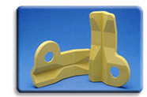
  NexPrene TPEs
  Colorable 9000 Series Materials

The materials in the NexPrene® 9000 series are fully vulcanized thermoplastic elastomers, ranging in hardness from 25 Shore A to 50 Shore D. Each of these materials has a clean, white, natural appearance for ease and economy of coloring. All the materials in the series are non-hygroscopic, so they require no pre-drying for injection molding or extrusion.
Materials in this series exhibit mechanical properties — such as resistance to compression set or oil swell — that are as good as, or superior to, conventional TPEs. In addition, parts produced using grades in the NexPrene 9000 series demonstrate very low fogging characteristics.
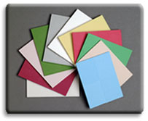
The combination of colorability and performance makes materials in the NexPrene 9000 series suitable for demanding applications where bright or subtle colors are desired, such as consumer products, automotive interiors, or automotive and construction weatherseals.
NexPrene® 9000 series — Technical Data
Products in this series are identified by their hardness ratings in the last two positions of the product name — e.g., NexPrene 9055A TPE has a nominal hardness that measures 55 Shore A. For technical data on one of the materials in the 9000 series, click on the product designation below:
NexPrene 9035A  NexPrene 9040A  NexPrene 9045A  NexPrene 9050A | NexPrene 9055A  NexPrene 9060A  NexPrene 9065A  NexPrene 9075A  NexPrene 9080A | NexPrene 9085A  NexPrene 9090A  NexPrene 9040D  NexPrene 9050D

